Systems Development:
Object Oriented
Analysis and Design

H172 35

Assessment
LO 2,3

Student |  | Kamil Milej
I.D. |  | 2264629
Date |  | 16/12/2024
 | Pass |  |  | Fail |  | Remediation
Tutor

Outcome 3 - Stage 2 — Testing

After completing Stage 1 you are required to develop a test plan and test the completed program. The test log should identify any areas where the program fails, and detail any fixes and retests required.

You will be required to submit your test plan with evidence of testing. This will include any retest after fixes.

Test Strategy :

There is a lot of options for testing, but I will concentrate on Unit Testing, Integration Testing, System Testing, Acceptance Testing, UI Testing.

- Unit testing, I use it to test simple methods or small isolated code (TO21) where we check how work one method.
- Integration testing, which I use to test the correlation between different modules of the system to be sure everything works fine.
- System testing, I use it to test the whole system in one, like showing all users or items in stock.
- Acceptance testing, I use this kind of testing to ensure the interface for the user is readable and straightforward to use.
- UI testing, to ensure all functionality in interface/UI works fine, like login validation with correct and incorrect data, also show the history of user loan.

Type of test | Example of test
Unit testing | T020a, T021, T020.1, T023
Integration testing | T013, T022
System testing | T015, T016, T017
Acceptance testing | T018, T019
UI testing | T001, T002, T007, T014

Test Plan
Candidate: Kamil Milej Project Title: Glencaldy Learning Centre
Test Case ID | Test Case Function | Test case | Test Steps | Test data | Expected result | Post Condition | Actual result | Comments/Status
T001 | Login Validation | Test valid login | 1. Enter valid User ID and password  2. Click "Login" | ID: admin, Password: admin123 | Login successful, admin user logged in | Show Main Menu | As expected | 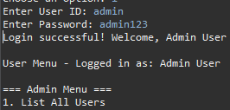
T002 | Login Validation | Test login with incorrect password | 1. Enter valid User ID  2. Enter incorrect password  3. Click "Login" | ID: admin, Password: wrongpassword | Error message: "Invalid User ID or Password" | No user logged in | As expected | 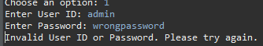

Test Case ID | Test Case Function | Test case | Test Steps |  | Test data |  | Expected result |  | Post Condition |  | Actual result |  | Comments/Status
T003 | Registration | Test registration of a new user | 1. Select "Register" option  2. Fill in user details |  | Username: newuser, Password: test123, First Name: John, Last Name: Doe, Account Type: Casual |  | New user successfully registered |  | User is visible in the user list |  | As expected |  | 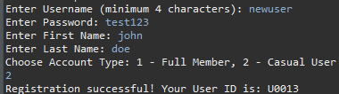
T004 | Registration | Test registration with an existing username | 1. Select "Register" option  2. Fill in user details with an existing username |  | Username: admin |  | Error message: "Username already exists |  | No changes in the user list |  | As expected |  | 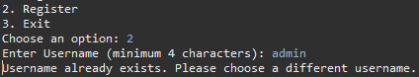
T005 | Change Password | Test password change | 1. Log in  2. Select "Change Password"  3. Enter old and new passwords |  | Old Password: test123, New Password: newpass456 |  | Password successfully changed |  | Password updated in the system |  | As expected |  | 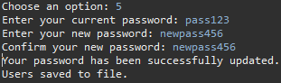
Test Case ID | Test Case Function | Test case | Test Steps |  | Test data |  | Expected result |  | Post Condition |  | Actual result |  | Comments/Status
T006 | Search Catalog | Search for an existing title | 1. Enter an existing title in the search bar |  | Title: Java programming |  | Catalog item found, details displayed |  | No changes in the catalog |  | As expected |  | 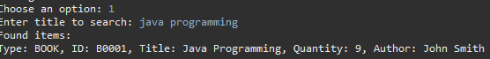
T007 | Search Catalog | Search for a non-existent title | 1. Enter a non-existent title in the search bar |  | Title: Non exist Title |  | Message: "No search results found" |  | No changes in the catalog |  | As expected |  | 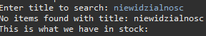
T008 | Add Stock Item | Add a new item to the catalog | 1. Select "Add Item" option  2. Enter new item detail |  | Title: New Book, Quantity: 5, Type: Book, Author: Kamil Milej |  | Item successfully added |  | New item is visible in the catalog |  | As expected |  | 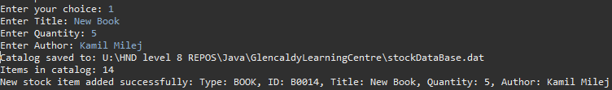
T009 | Edit Stock Item | Edit an existing item | 1. Select an item from the catalog  2. Change its name |  | Old title : new book  New title: latest book |  | Title updated in the item's details |  | Catalog updated |  | As expected |  | 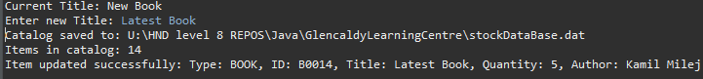
T010 | Delete user | Delete an user from the catalog | 1. Select an user ID  2. Confirm deletion |  | Username: newuser |  | User successfully deleted |  | User removed from the catalog |  | As expected |  | 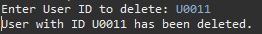
T011 | Reserve Stock Item | Reserve an available item | 1. Select an item from the catalog  2. Enter reservation details |  | Title: Java Programming, |  | Reservation completed successfully, quantity reduced in stock |  | Reservation added to user history, quantity reduced |  | As expected
Test Case ID | Test Case Function | Test case | Test Steps | Test data |  | Expected result |  | Post Condition |  | Actual result |  | Comments/Status
T013 | Loan Creation | Create a new loan record | 1. log into Admin acc  2. Fill details  3. confirm loan | Title : java programming |  | Loan successfully registered, quantity reduced in stock |  | Loan record added, quantity reduced |  | As expected |  | 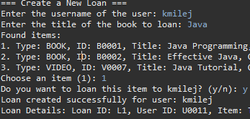
T014 | Loan History | Display user’s loan history | 1. Log in as admin  2. Select "Loan History" option | none |  | All user loans displayed |  | No changes in data |  | As expected |  | 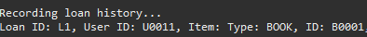
T015 | Display All Users | Display the list of user | 1. Log in as an admin  2. Select "List Users" option | none |  | User list displayed |  | No changes in the system |  | As expected |  | 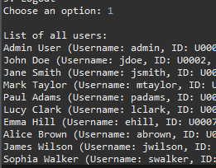
T016 | Add User | Add a new user | 1. Log in as an admin  2. Select "Add User" option  3. Enter user details | Username: emilej pass:  Emilej type:  Casual |  | User added successfully |  | New user is visible in the user list |  | As expected |  | 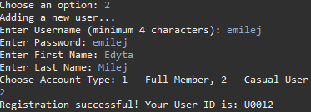

Test Case ID | Test Case Function | Test case | Test Steps | Test data | Expected result | Post Condition | Actual result | Comments/Status
T017 | Login History | View Login History | 1.Log in as Full Member  2. Select View Login History | none | List of last login | No changes in the system | As expected | 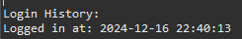
T018 | User Menu | Full Member Menu | 1.log in as fullMember  2. press enter at choice option  3. type something | Enter – empty input  Next – any input | Chance to choose option after it | No changes in the system | Error | 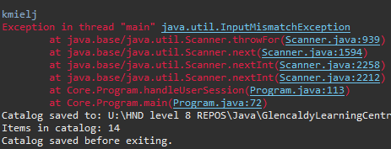
T019 | Registration | Test registration of a new user | 1. Select Register option  2. after try to back if change mind | none | Back to starting menu | No changes in the system | Error | 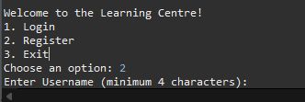
T020 | Add Stock Item | Add a new item to the catalog | 1. Select "Add Item" option  2. Enter new item details | Title: Javaforever  Quantity:  -10, duration 1200m | Error quantity cant be less then 0 | No changes in the system | System let as make stock with -10 quantity | 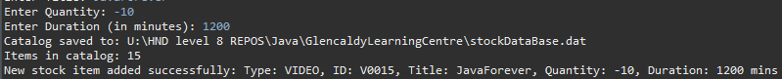

Test Case ID | Test Case Function | Test case | Test Steps | Test data | Expected result | Post Condition | Actual result | Comments/Status
T021 | Edit Stock Item | Edit an existing item | 1. Select an item from the catalog  2. Change a quantity | 1. Id of item: any item  2. quantity change from any value to minus value | Error system should us not give this option | No changes in the system | System let us make changes from positive or negative value to negative value

Fixed bugs from test plan :
Test Case ID | Test Case Function | Test case | Test Steps | Test data | Expected result | Post Condition | Actual result | Comments/Status
T020a | Add Stock Item | Add a new item to the catalog | 1. Select "Add Item" option  2. Enter new item details  3. Enter quantity  -10 | Title: About Life  Quantity:  -10, | Quantity cannot be negative. Please enter a valid positive value. | No changes in the system | As expected | 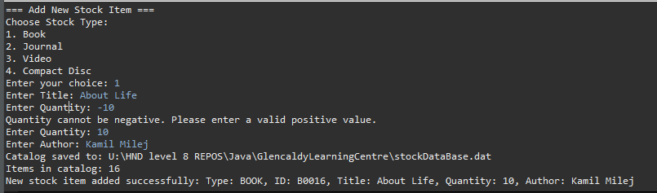
T020.1 | Loan quantity | Admin Menu - loan | 1.Log into admin  2. Make new loan  3. Quantity should decreased by 1 not 2 | Loan lord of the ring book | From 25 quantity should be after loan 24 | System should record -1 in quantity | As expected | 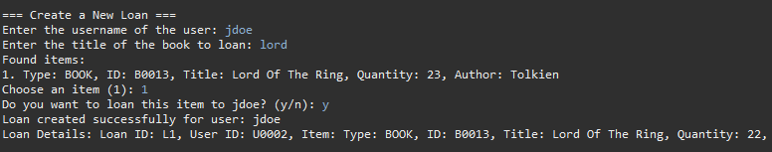
T022 | Loan being returned | Admin menu – return loan | 1.Login into admin  2. Create loan  3. Return loan | Loan lord of the ring book and  Return | quantity will decrease by 1 and increase by 1 when return | System should change value by -1 and add value +1 | As expected | 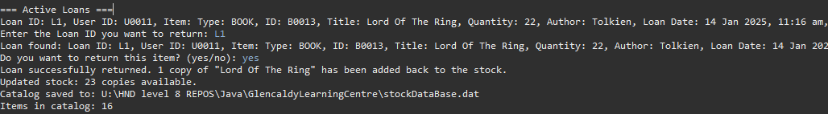

Test Case ID | Test Case Function | Test case | Test Steps | Test data | Expected result | Post Condition | Actual result | Comments/Status
T023 | Method overloading | system | Make objects using overloading | extraContent | Will make object with extra properties | Additional properties in an object can include videos with or without extra content. | As expected | 